<Project Name>

Use-Case Specification: <Use-Case Name>

Version <1.0>

[Chữ in nghiên màu xanh là hướng dẫn. Cần bỏ tất cả hướng dẫn trước khi nộp.

Các em có thể viết bằng tiếng Anh hay tiếng Việt.]

Revision History

|  |  |  |  |
| --- | --- | --- | --- |
| **Date** | **Version** | **Description** | **Author** |
| <dd/mmm/yy> | <x.x> | <details> | <name> |
|  |  |  |  |
|  |  |  |  |
|  |  |  |  |

Table of Contents

1. Use-case Model 4

2. Use-case Specifications 4

2.1 Use-case: Add a product to cart 4

2.2 Use-case: Create a new account 5

# Use-case Model (Mô hình use-case)

[*Put an image of the use-case diagram modeling all use-cases in this section. The diagram below is just for example*]

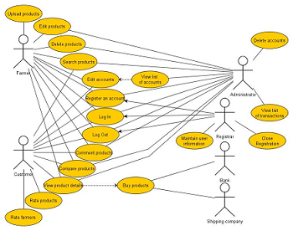

# Use-case Specifications (Đặc tả use-case)

*[Bên dưới là ví dụ đặc tả cho một use-case]*

## Use-case: Add a product to cart

|  |  |
| --- | --- |
| Use case Name  (Tên use-case) | Add a product to cart. |
| Brief description  (Mô tả) | This use case describes how the Customer can buy a product. |
| Actors  (Actors) | Customer |
| Basic Flow  (Luồng cơ bản) | 1. At the homepage, the user enters keywords on the ‘Search’ field 2. Users clicks on ‘Search’ button to start searching a product 3. System displays the products found 4. User clicks ‘Add to cart’ button on the expected product 5. System adds a new product to shopping cart 6. System displays the quantity of all products in the cart to the user |
| Alternative Flows  (Các luồng thay thế) | **Alternative flow 1: User cannot find products searched**   1. From #1 of the basic flow, user enters another term 2. Continue step #2 in the basic flow   **Alternative flow 2: Shopping cart has already had the product**   1. From #5 of the basic flow, system increases the quantity of the product 2. Continue step #6   **Alternative flow 3: …** |
| Pre-conditions  (Điều kiện đầu vào) | User goes to homepage at [www.hailua.com.vn](http://www.hailua.com.vn) |
| Post-conditions  (Điều kiện đầu ra) | The user successfully adds new item to the cart or increases quantity of the existing item in the cart. |

## Use-case: Create a new account

....